FACULTY EVALUATION
Programme Name: SEP Scale Alumni Masterclass Module 1 Uganda (11th May 2026 - 15th May 2026)
Session: Reflection of SEP Learning
Faculty Name: Dr. Tom Buringuriza
No. of Respondents: 12
No. of Participants: 12
Evaluation Parameter | (%) Individual Score | (%) Programme Average
Punctuality (Commencement and Completion of Sessions) | 93 | 93
How well do you understand the core concepts presented? | 87 | 94
Rate your confidence in applying the new skills learnt | 87 | 87
Degree of Faculty preparedness for the sessions | 95 | 94
Content and methodology of the program | 93 | 94
Quality of class and group discussions | 92 | 88
The information presented in the course is relevant to my work (ministry) | 100 | 94
Average scores | 92 | 92

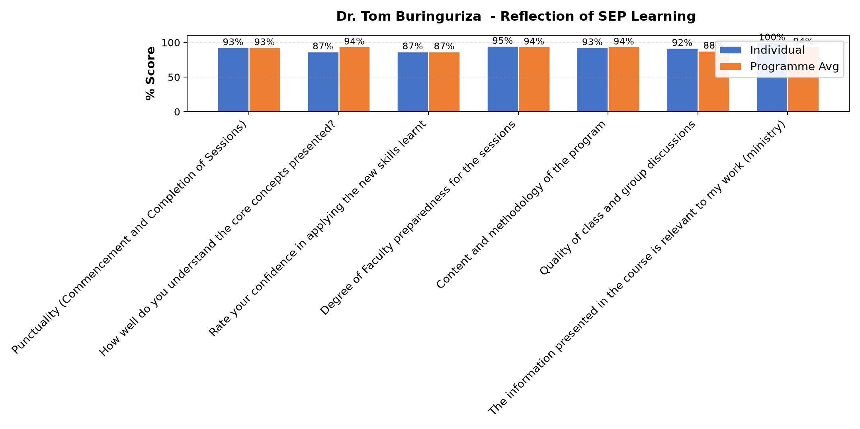

Comments & Feedback
- • Finances,
- • No barriers at all.
- • follow up session must be continuous
- • I will implement..no barrier
- • Busy work schedules
- • I aquired new ideas which have motivated me to chase our entrepreneurial goal.
- • Opportunity ,environment, negativity from others, lack of support and rejection to welcome my opinions
- • No barriers.
- • Busy work schedules
- • The costs of data are too high
SUBMITTED THROUGH:
SBS Evaluation Automation System

